Newmor Wallcoverings Backings Guide

What is vinyl wallcovering – Why Wallcoverings?

Our Vinyl wallcoverings are available in endless textures, colours and designs, from tactile textiles and geometric prints to surfaces made specifically to be durable and hygienic. The advantages of using vinyl wallcovering include being flame retardant, hard-wearing, light and colourfast, cleanable, durable, easy to install and maintain, resistant to scratches and impact, and protection against stains and chemicals, with a long lifespan of up to 15 years.

Grounds and Substrates – there are three backings we use in manufacturing our wallcoverings:
- Paper Backing:
  - Material: This backing is made of paper.
  - Benefits: Paper backing is lightweight and easy to install. It's often less expensive compared to other backings.
  - Uses: suitable for less high-traffic areas and places where humidity is not an issue, such as residential spaces.

- Fabric Backing:
  - Material: Fabric backing is a woven a textile.
  - Benefits: It adds a level of texture and durability to the wallcovering. It can also provide some insulation and sound absorption.
  - Uses: Commonly used in commercial spaces where there is moderate to high traffic. It's also good for areas where a more luxurious or textured appearance is desired.
  - Scrim (made from cotton) and Osnaburg – (made from a polycotton mix with higher tensile strength) are types of Fabric Backing.

- Non-Woven Backing:
  - Material: Composed of synthetic or natural fibres in a non-woven structure.
  - Benefits: Non-woven backings are durable, breathable, and resistant to moisture. They are often easy to install as they can be applied directly to the wall without soaking.
  - Uses: Ideal for high-traffic areas, commercial spaces, and places prone to humidity such as bathrooms and kitchens.
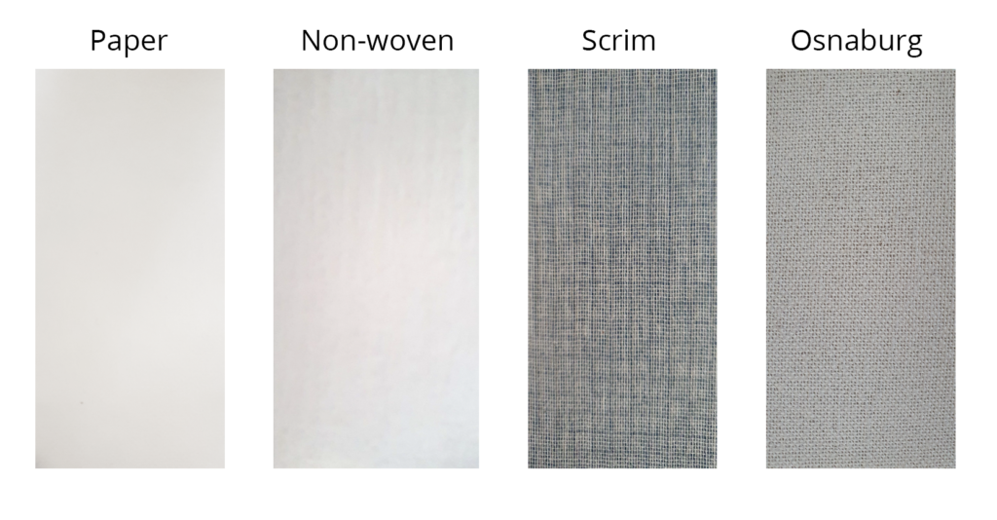

Types and Usage
Wallcoverings can be used in virtually any residential or commercial environment. Since there are many different types of wallcoverings on the market, it is important to understand the qualities of each type and in what type of environment the wallcoverings will be used.
- When selecting wallcoverings, the first variable to consider is the amount of traffic the area will receive.
- Paper and natural wallcoverings are most appropriate where traffic is minimal. They are more delicate than their vinyl counterparts yet offer ample durability and a special style to a variety of placements.
- Vinyl and synthetic textiles, with their maximum durability and ease of cleaning, are especially appropriate for hospitals, sporting arenas, schools, and other high-traffic situations.
- While wallcoverings are categorized by residential and contract segments, it is not uncommon to use residential wallcoverings in contract settings, like assisted living facilities for a homey feel, for instance, or to use contract wallcoverings in homes.

Categories of vinyl wallcovering we manufacture are:
- Type I (Light Duty) – is designed to be used in areas of light to moderate traffic. They typically fall in the range of 250 to 400gsm.
- Type II (Medium/Heavy Duty) – is for use in high traffic areas, such as corridors, public spaces, schools, etc. Typically, the weight in this category will be wallcoverings upwards of 460gsm.

